PROJECT REPORT

**SUBSCRIBERS GALORE-**

**EXPLORING WORLD’S TOP YOUTUBE CHANNELS**

1. **INTRODUCTION**
   1. **OVERVIEW**

The project titled “Subscribers Galore: exploring world’s top YouTube channels” aims to analyze the YouTube is a place where people share videos, and some of these channels have become incredibly popular. We will be exploring channels that make videos about many different things, like funny skits, travel adventures, and even teaching you interesting stuff. Some channels have millions of fans who love to watch their videos. In the dynamic realm of online content, YouTube has emerged as a global powerhouse for creators and viewers alike. With millions of channels spanning various genres, it's a universe of entertainment, education, and inspiration. To navigate this vast world and uncover the most influential and captivating YouTube channels, we turn to Tableau, a powerful data visualization tool.

Exploring the world's top YouTube channels with tableau is a journey of discovery. By leveraging Tableau's capabilities, we can dive into the data behind the world's most-subscribed channels, unveiling trends, demographics, and engaging content types. We will decipher the most-viewed videos, uncover emerging stars, and analyse the factors contributing to their success.

This exploration is not just for data enthusiasts but for anyone curious about the internet's cultural landscape. It's a window into the digital zeitgeist, shedding light on the channels that resonate with millions worldwide. So, join us as we embark on a visual adventure, uncovering the fascinating stories behind the top YouTube channels, and gain insights into the ever-evolving world of online video content.

* 1. **PURPOSE**

The purpose of exploring the world's top YouTube channels using Tableau is to gain valuable insights and understanding about the online video content landscape. This exploration helps us identify trends, patterns, and key factors contributing to the success of these channels.

Beyond entertainment, exploring top YouTube channels serves an educational purpose. Many channels provide valuable insights, tutorials, and educational content, making it an invaluable resource for knowledge acquisition and skill development. This aids lifelong learning and personal growth.

By using Tableau, a powerful data visualization tool, we can create informative and visually engaging representations of the data behind YouTube channels. In simple terms, exploring the world's top YouTube channels using Tableau is a way to understand what makes the best channels tick, helping content creators, businesses, and anyone interested in the world of online video content gain insights into the digital landscape.

1. **PROBLEM DEFINITION & DESIGN THINKING**
   1. Empathy Map

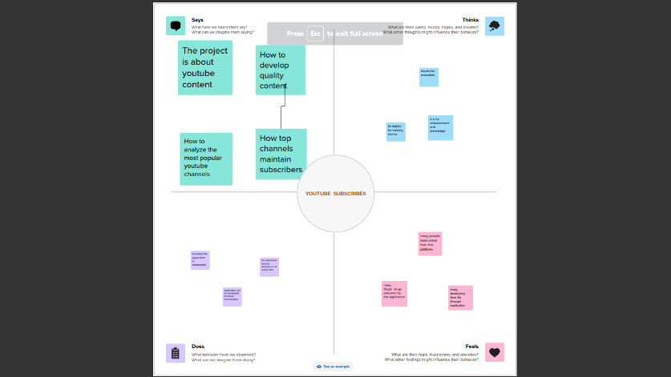

* 1. **Ideation & Brainstorming Map**

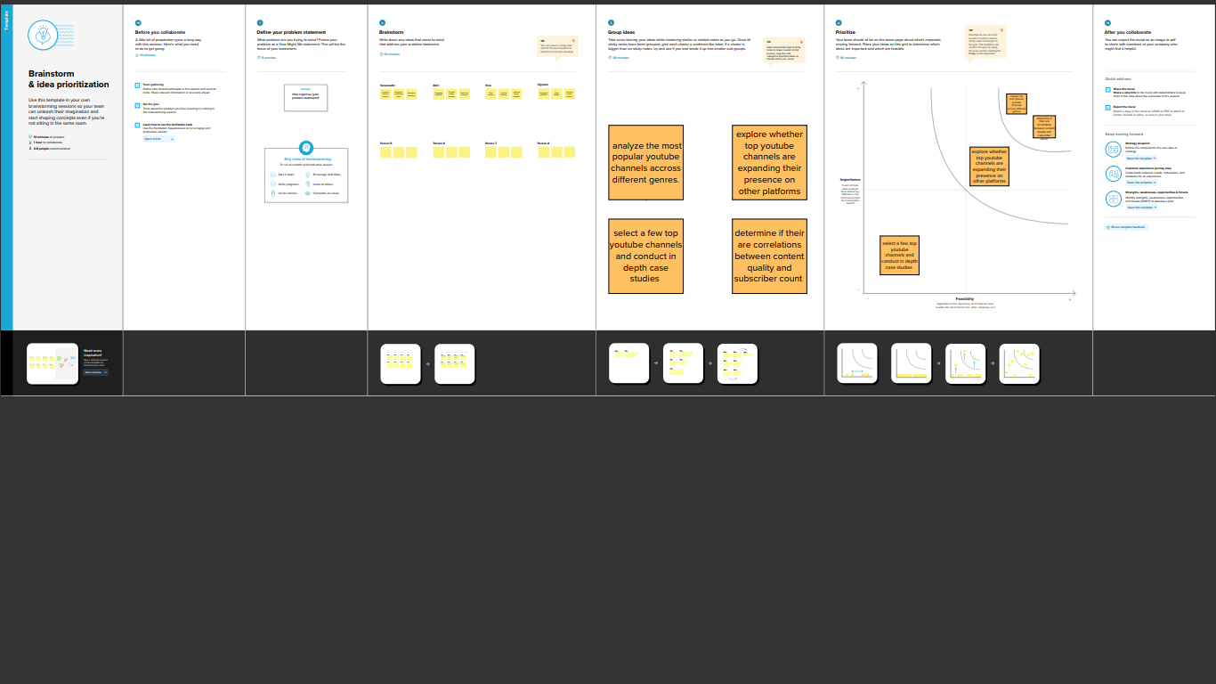

1. **RESULT**

Rank wise Channel

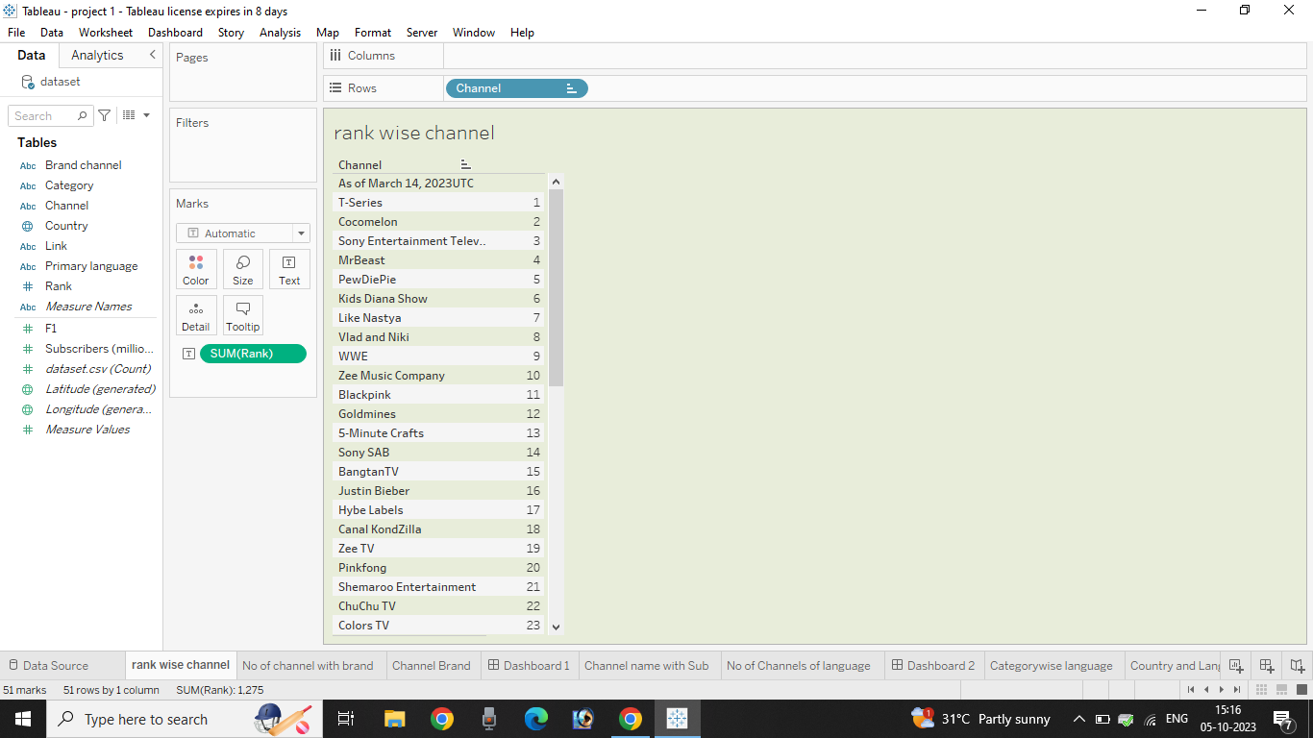

NUMBER OF CHANNELS WITH BRAND

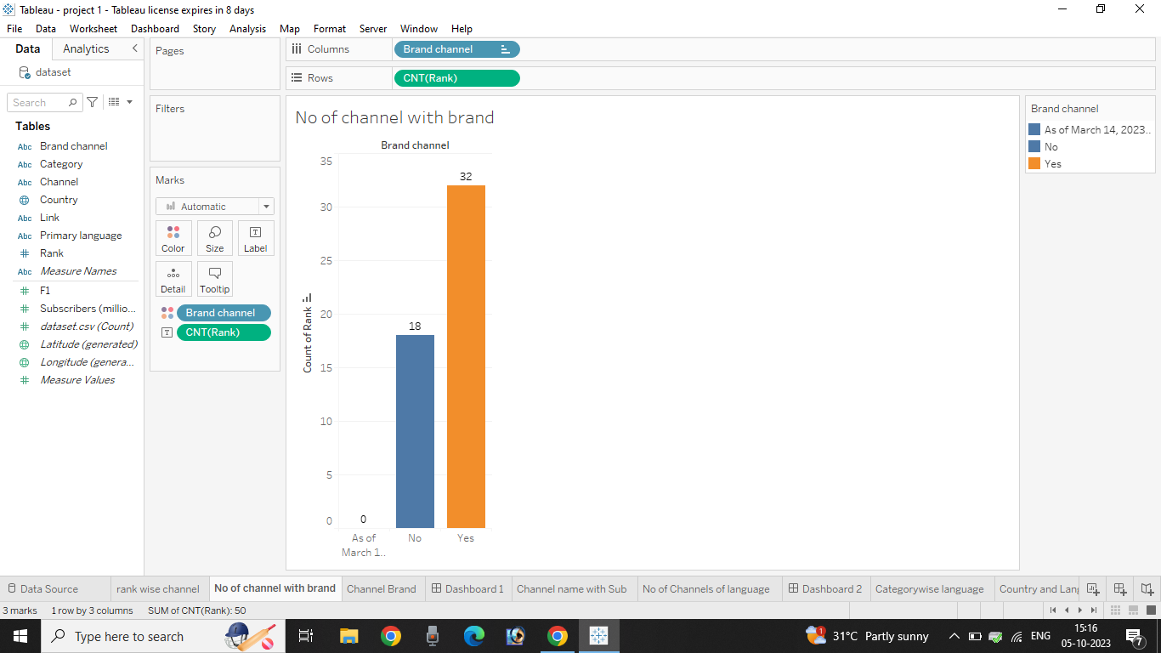

CHANNEL BRAND

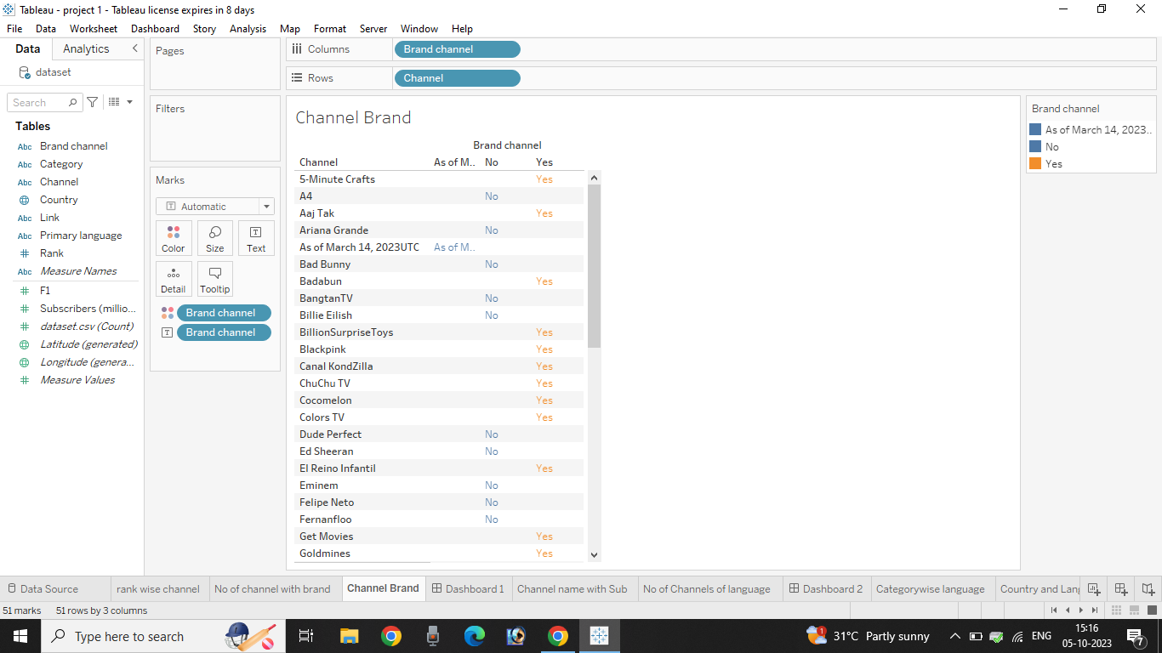

DASHBOARD 1

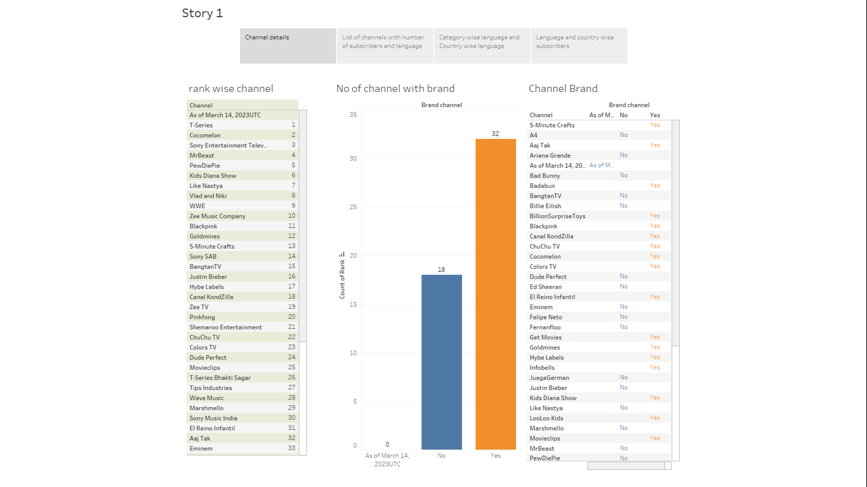

CHANNEL NAME WITH SUBSCRIBERS

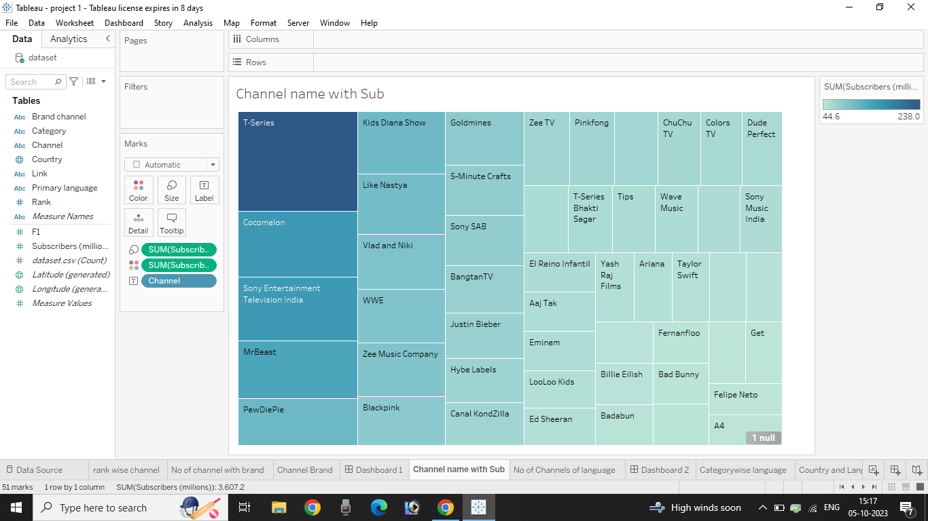

NO OF CHANNELS OF LANGUAGE

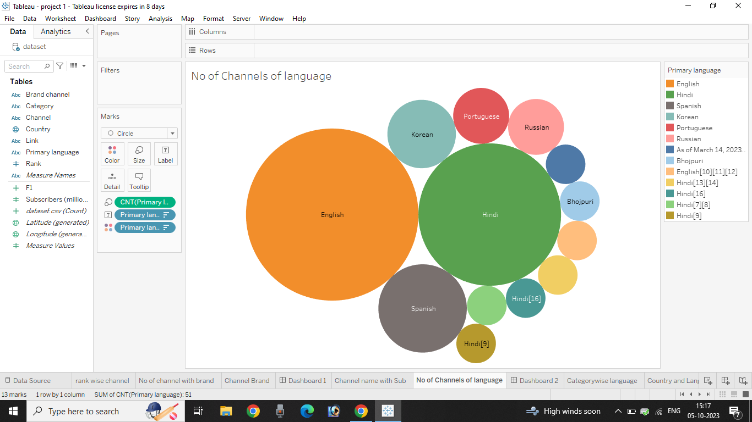

DASHBOARD 2

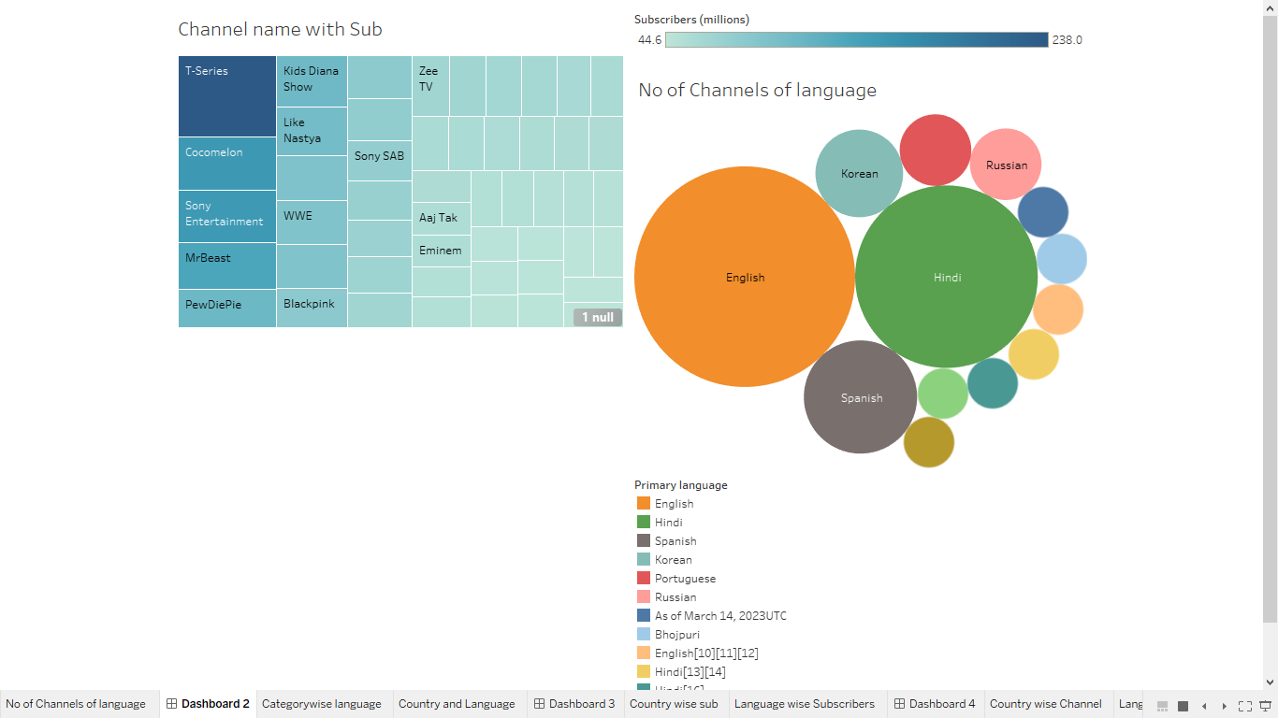

**CATEGORY WISE CHANNEL**

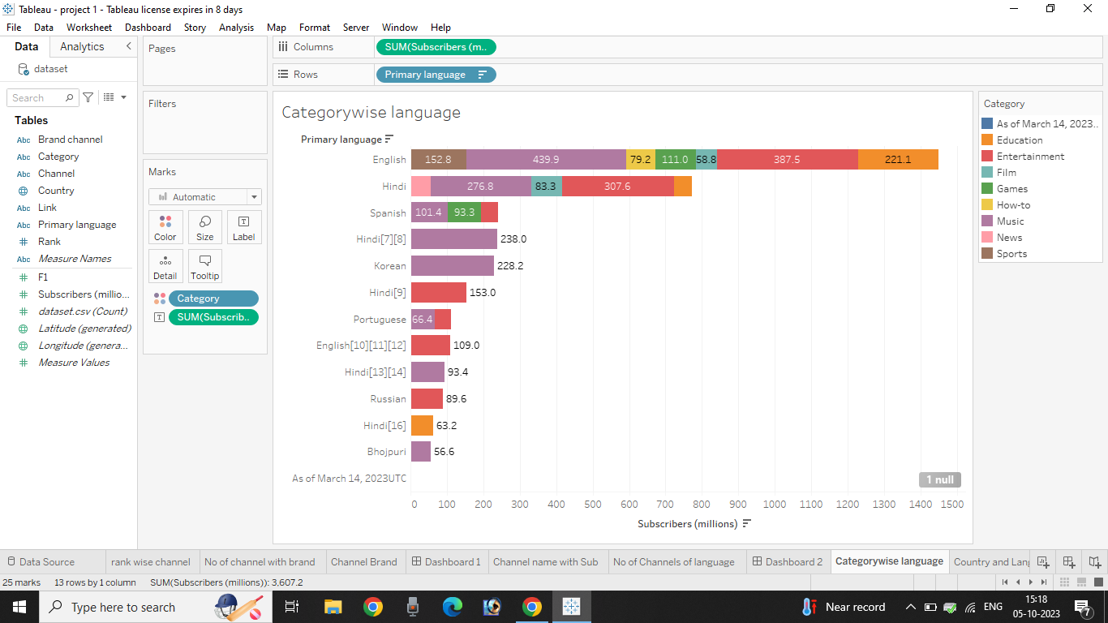

COUNTRY AND LANGUAGE

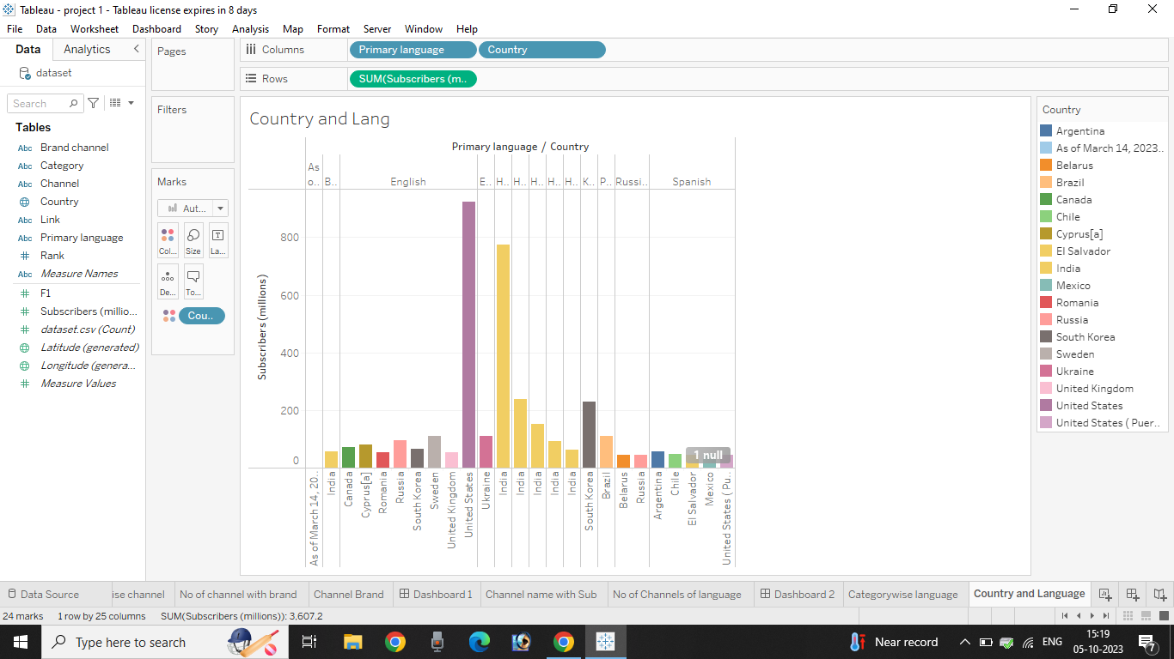

DASHBOARD 3

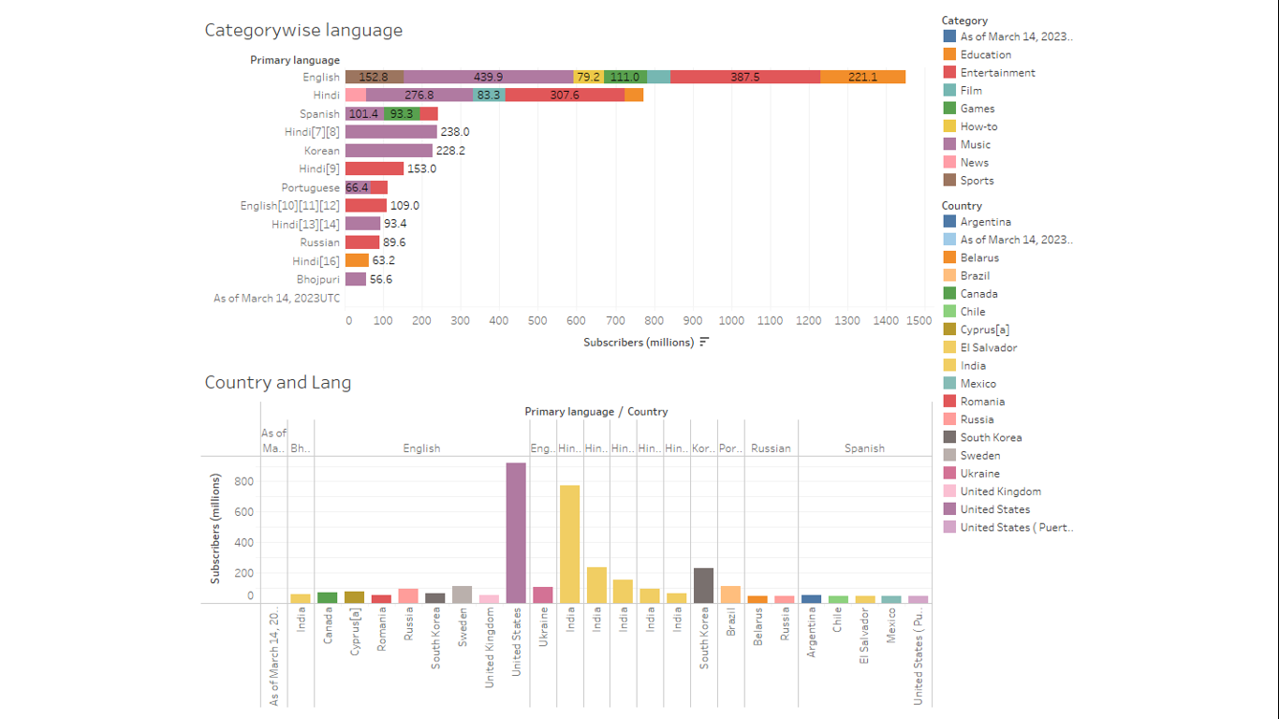

**COUNTRY WISE SUBSCRIBERS**

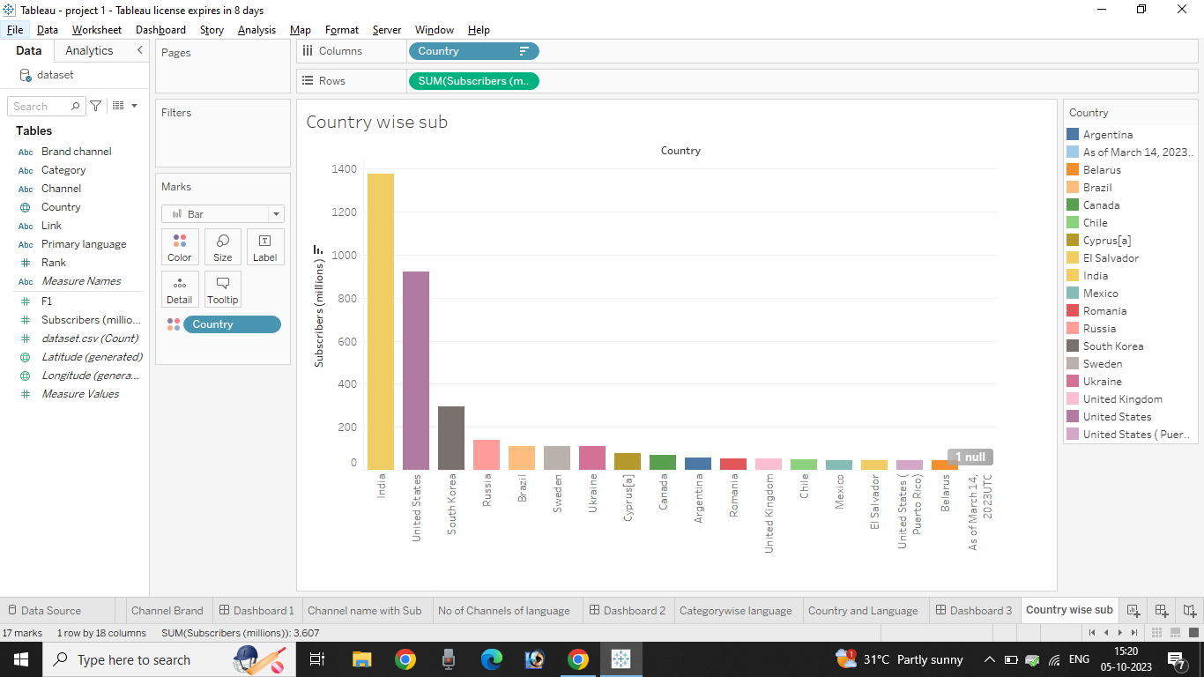

**LANGUAGE WISE SUBSCRIBERS**

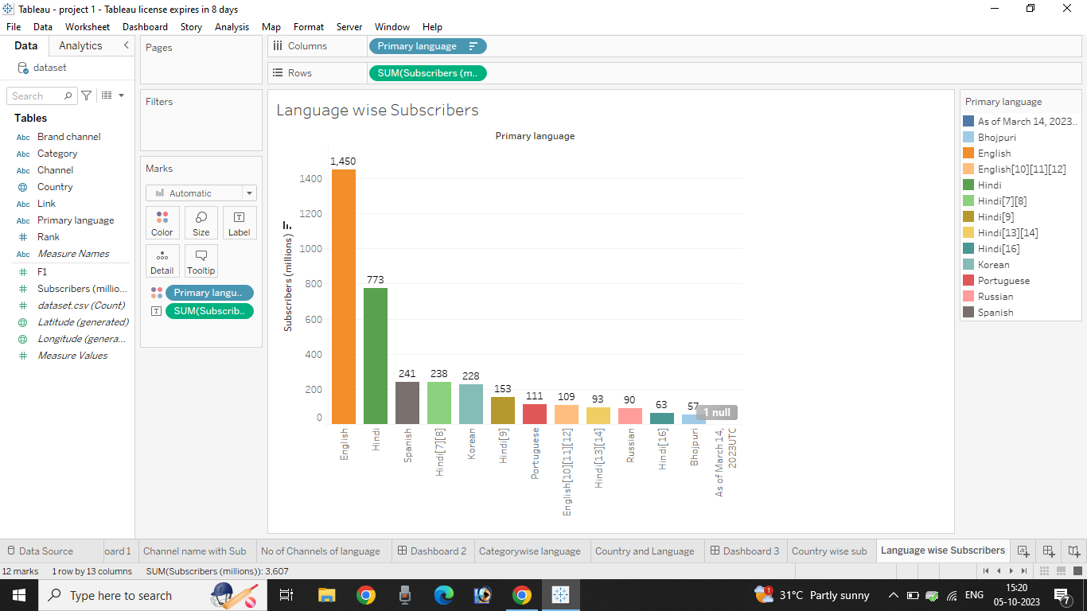

**DASHBOARD 4**

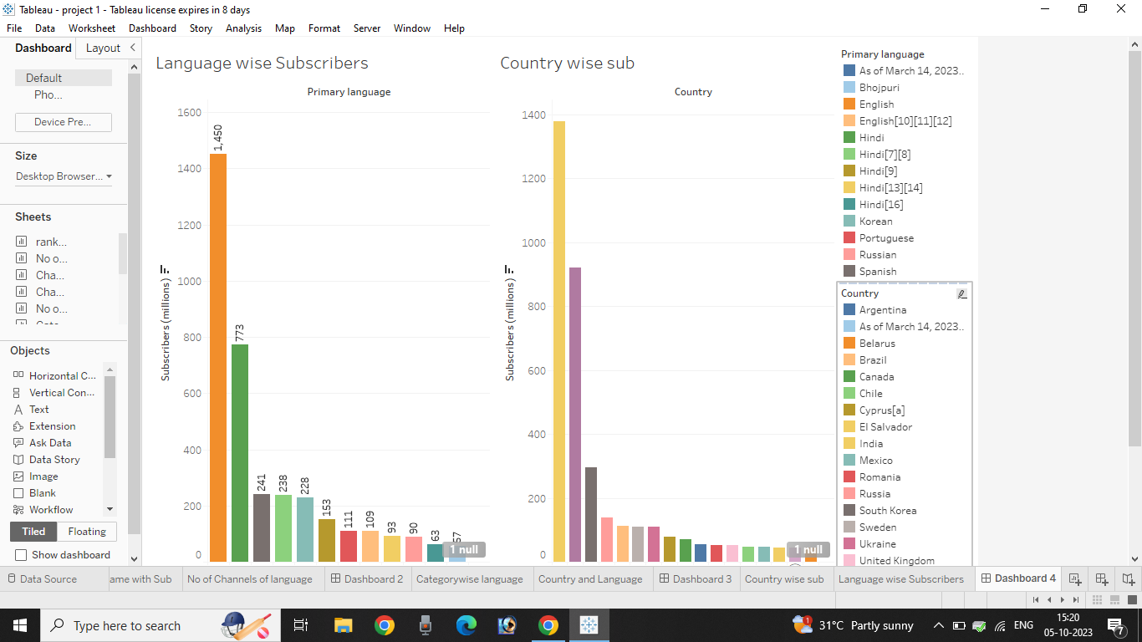

**COUNTRY WISE CHANNEL**

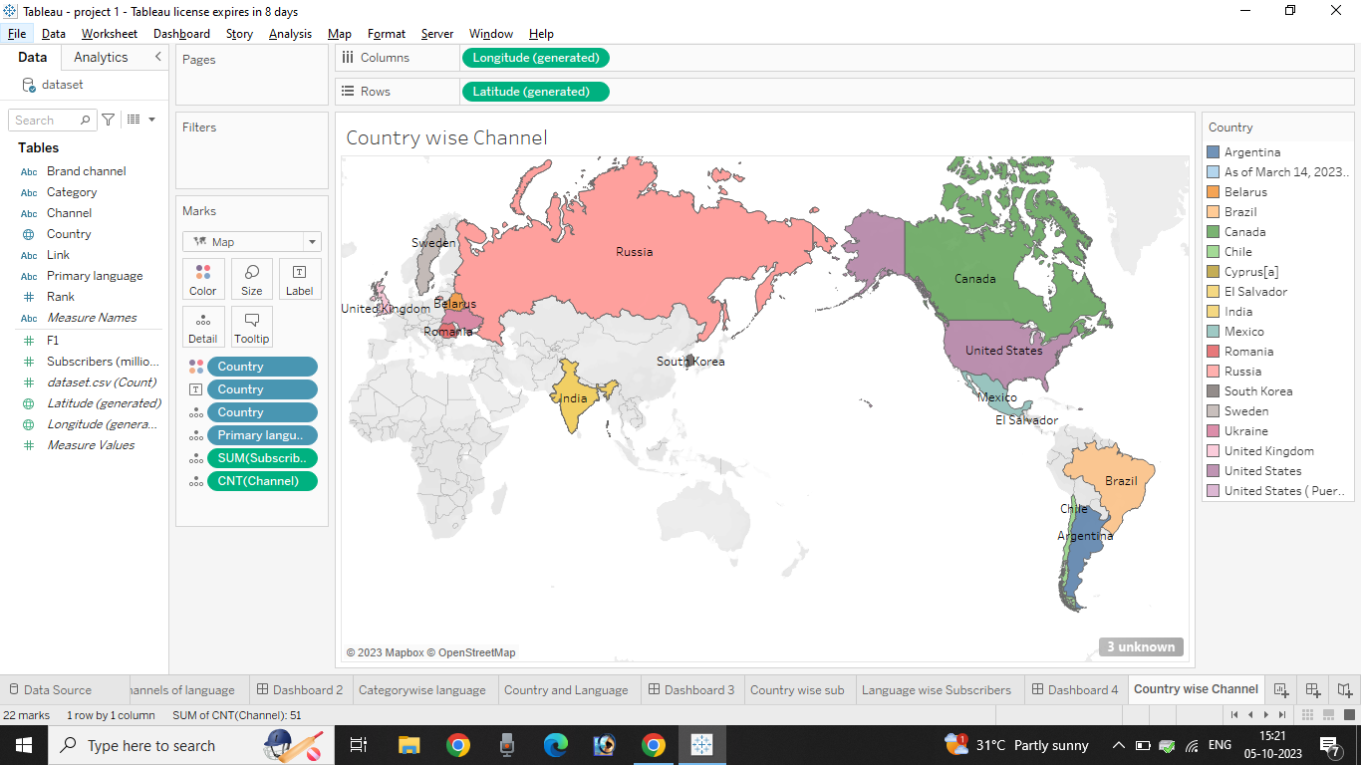

**LANGUAGE WISE CHANNEL**

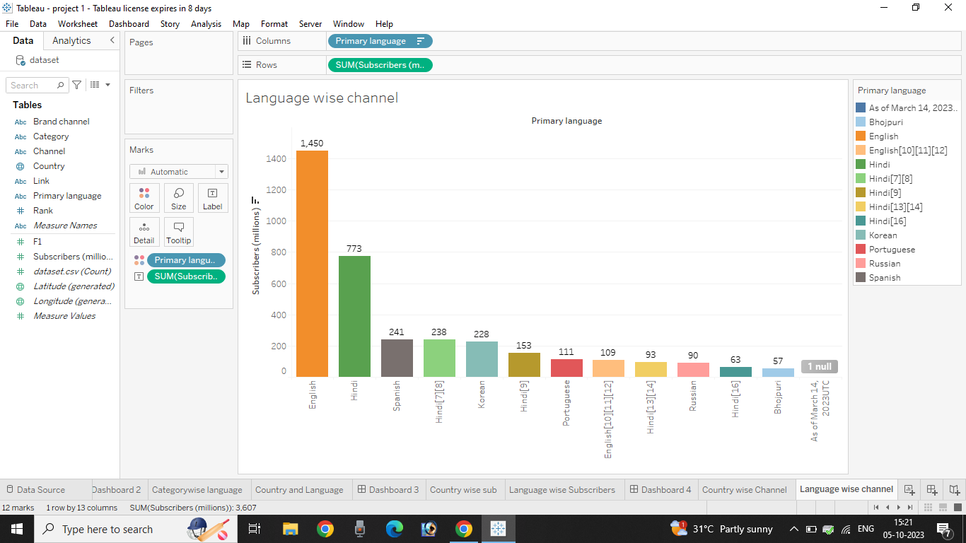

**STORY 1**

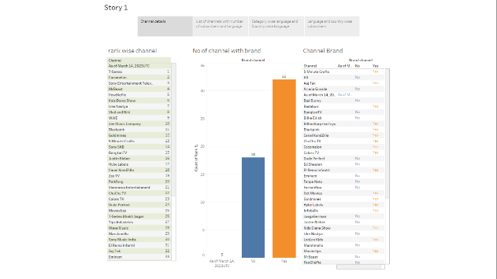

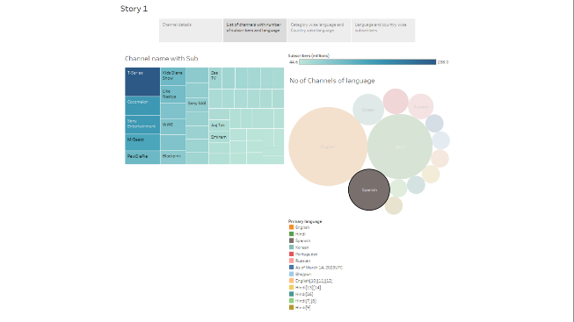

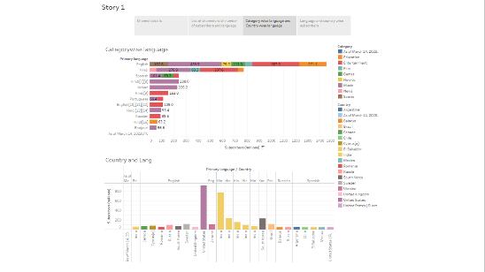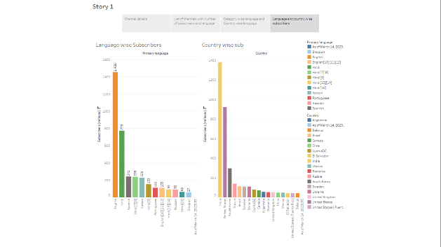

1. **ADVANTAGES AND DISADVANTAGES**
   1. **Advantages**

Exploring the world's top YouTube channels using Tableau offers several significant advantages:

Data Visualization: Tableau's user-friendly interface and data visualization capabilities make it easy to transform complex data into insightful charts, graphs, and dashboards, allowing for a clear and intuitive understanding of YouTube channel performance.

Real-time Analysis: Tableau can connect to live data sources, enabling real-time analysis of YouTube channel metrics. Creators and marketers can make quick, data-driven decisions as trends unfold.

Customization: Users can customize Tableau dashboards to focus on specific KPIs or areas of interest. This flexibility allows for a tailored approach to data analysis, making it relevant to various stakeholders.

Data Integration: Tableau can integrate with a wide range of data sources, allowing users to combine YouTube data with other sources like social media, website analytics, and more for a holistic view of their online presence.

Accessibility: Tableau Server and Tableau Online enable sharing and collaboration, making it easy for teams to access and interact with data visualizations from anywhere, fostering better teamwork and communication.

Informed Decision-Making: The insights gained from Tableau's analysis empower content creators, marketers, and businesses to make informed decisions, leading to more effective content strategies, audience targeting, and revenue optimization.

In conclusion, Tableau's strengths lie in its ability to simplify data analysis, offer real-time insights, and drive data-informed decision-making in the dynamic world of YouTube content creation and marketing.

* 1. **DISADVANTAGES**

While exploring the world's top YouTube channels using Tableau offers numerous advantages, there are also some disadvantages to consider:

Complexity: Tableau can be complex for beginners. Setting up the software, connecting to data sources, and creating effective visualizations may require a steep learning curve, which can be time-consuming.

Cost: Tableau is a paid tool, and its licenses can be expensive. This cost may be prohibitive for individuals or small organizations with limited budgets.

Data Privacy: Handling data from YouTube channels, especially if not done carefully, can raise concerns about privacy and data security. Unauthorized access to sensitive information could lead to privacy breaches.

Data Overload: Tableau can provide a vast amount of data and insights, which can be overwhelming. Without a clear focus on what data is relevant, users may find themselves lost in information without a clear direction for action.

Hardware Requirements: Tableau can be resource-intensive, requiring powerful computers or servers to handle large datasets effectively. This can be a disadvantage for users with limited computing resources.

Maintenance: Regular maintenance and updates are necessary to ensure Tableau continues to work effectively. This can be time-consuming and may require dedicated IT resources.

In summary, while Tableau is a powerful tool for data analysis, it comes with complexities, costs, and potential privacy concerns that users need to be mindful of when exploring YouTube channel data.

1. **APPLICATIONS**

By Exploring the world's top YouTube channels using Tableau has numerous practical applications

content Strategy Optimization: Content creators can analyse top YouTube channels to understand what types of videos are most popular. This helps them refine their content strategy to attract a larger audience and boost engagement.

Audience Insights: Marketers can gain valuable insights into the geographic locations of a channel's audience. This information is critical for targeted advertising and collaborations with popular YouTubers to reach specific demographics.

Performance Tracking: Content creators and brand managers can track the performance of their channels over time, assessing factors like subscriber growth, video views, and audience retention. This data-driven approach helps refine their future content.

Competitor Analysis: By studying successful channels, businesses can gain a competitive edge by understanding what works and what doesn't in their niche. They can benchmark their performance against top channels to identify areas for improvement.

Investment Decisions: Investors can use Tableau to analyse the financial performance of YouTube channels, aiding them in making informed decisions about potential partnerships or acquisitions in the digital media space.

In sum, using Tableau for exploring top YouTube channels enables data-driven decision-making, helps optimize strategies, and offers insights that benefit content creators, marketers, and investors in the dynamic world of online video content.

1. **CONCLUSION**

Exploring the world's top YouTube channels with Tableau has been an eye-opening journey, providing valuable insights into the realm of online content creation. Through colourful and easy-to-understand visualizations, we've uncovered the secrets to their success. We've seen that channels covering a wide range of topics from music to gaming, vlogs, and educational content have garnered huge followings. Tableau has also allowed us to see the global impact of these channels, revealing where they have the most dedicated viewers.

In this data-driven analysis, we have learned that country wise, category wise, language wise subscribers, rank wise channel, No of channels with brand, language wise and country wise subscribers etc.

By understanding the dynamics of this digital landscape, we can adapt and stay ahead of evolving trends on YouTube. The power of data visualization, as demonstrated by Tableau, proves instrumental in comprehending this ever-changing online universe. As YouTube's influence continues to expand, the knowledge gained from this exploration will be a guiding light for those seeking to navigate and succeed in this dynamic digital world

1. **FUTURE SCOPE**

The future scope for exploring the world's top YouTube channels using Tableau is promising and multifaceted.

Content Optimization: As YouTube continues to evolve, creators will increasingly rely on data-driven insights to tailor their content strategies for maximum engagement. Tableau can aid in real-time analysis, enabling creators to adapt to changing viewer preferences swiftly.

Audience Expansion: Marketers will harness Tableau to expand the reach of YouTube channels by identifying untapped markets and devising targeted campaigns. The platform's ability to visualize data simplifies audience segmentation and localization efforts.

Predictive Analytics: With advancements in AI and machine learning, Tableau can be integrated to provide predictive analytics, forecasting trends, and identifying emerging content categories and audience behaviour.

Monetization Strategies: For both creators and businesses, Tableau can help in refining monetization strategies by analysing revenue streams, enabling data-backed decisions on ad placements, sponsored content, and merchandise sales.

Legal and Ethical Considerations: As content regulations evolve, Tableau can be used to monitor and ensure compliance with legal and ethical standards, safeguarding the future of YouTube channels.

The ongoing growth of YouTube and the power of data analytics suggest that Tableau's role in the YouTube ecosystem will continue to expand, aiding creators, marketers, and platform stakeholders in staying ahead in this dynamic digital realm.